**Test Automation – Assignment-I**

**Application to be tested - URL:**

https://www.ebay.com

**Tasks:**

* Go to ebay.com

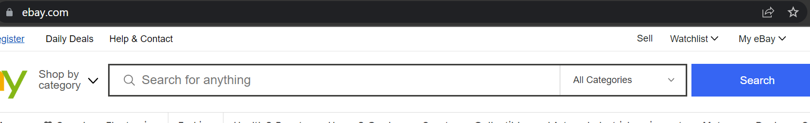

* Enter “Selenium” in searchbox

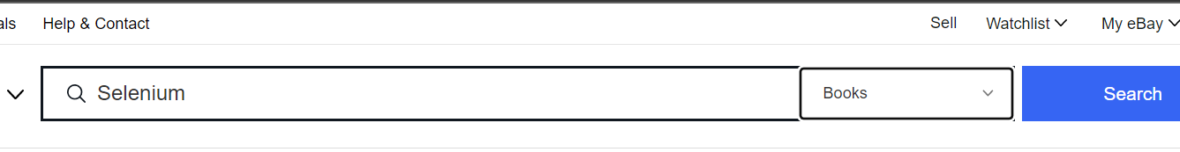

* Click Search button
* Click “Buy it now” tab

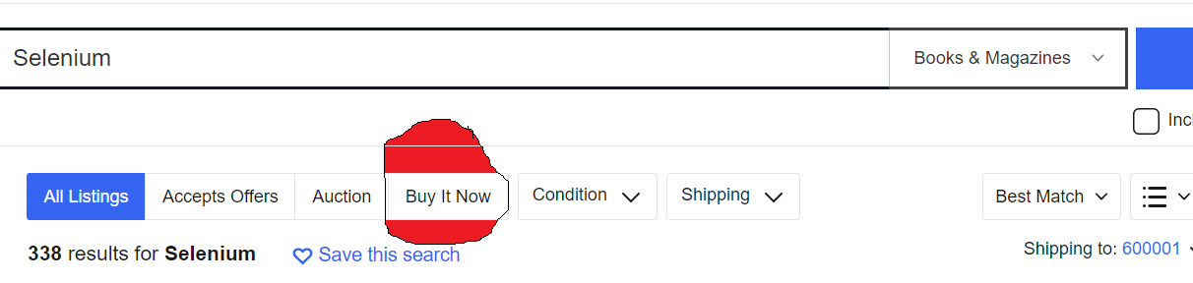

* Select “Time: newly listed”

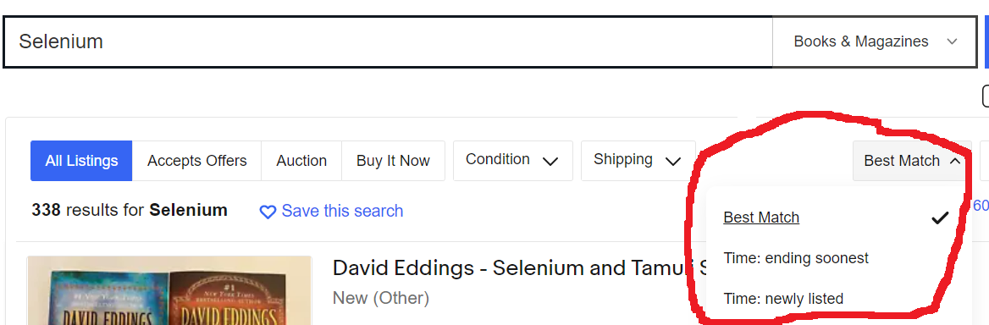

Validate if the item displayed at the top has current date with “Sep” in it.

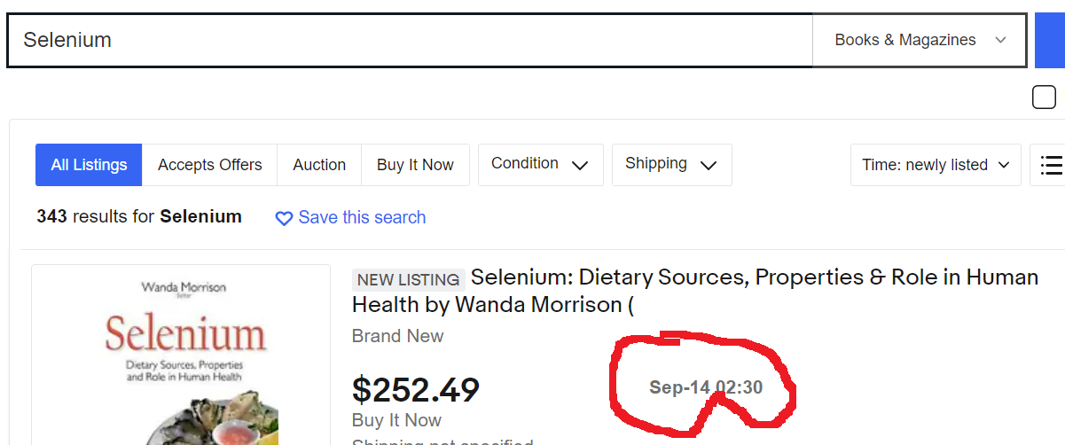

**Refer screenshot for each step**